#AACPSReadWithMe
Elementary School At-Home Reading Challenge
Read in the car or on the bus  ____________ | Read for 15 minutes  ____________ | Read while eating a snack  ____________ | Read on a rainy or snowy day  ____________ | Read for 10 minutes  ____________
Read to a sibling or neighbor  ____________ | Read with a friend  ____________ | Read while on the floor  ____________ | Read outside  ____________ | Listen to someone read to you  ___________
Read to a senior adult  ____________ | Take turns reading aloud with a friend  ____________ | Use your AACPL SAIL account to check out a book! | Listen to an audio book  ___________ | Read after school  ____________
Read to a parent or family member  ____________ | Turn out the lights and read by flashlight  ____________ | Read in bed  ____________ | Read for 20 minutes  ____________ | Read on a Saturday morning  ____________
Introduce yourself to a librarian  ____________ | Read in your pajamas  ____________ | Read about a character that doesn’t look like you  ____________ | Read before school  ____________ | Read in your favorite room  ____________

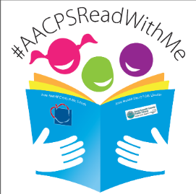

Write the name of the book on the line to complete the square and earn BINGO!
Name:________________ Grade: ____ Teacher: _______________
Parent/Guardian or Teacher Signature: ______________________

